

**#AGiveAwayApp**

**Application Architecture Document**

**Document Version: 1.0**

Table of Contents

1. Application Name and Team Details 2

2. HackFSE Theme Introduction 2

3. Use Cases Overview 3

4. Process Flow Diagram for #GiveAwayApp 7

5. Micro Service Architecture Implementation Overview 7

6. Database Design 9

7. References 22

# Application Name and Team Details

Application Name: **#GiveAway**

Team Name: **Sunshiners**

Program Name: **Hack FSE using Java Stack**

Team Members:

1. Anshul Gautam (Cognizant Emp Id: 683576)
2. Sweta Rani (Cognizant Emp Id: 504024)
3. Bhaskar Koley (Cognizant Emp Id: 676225)

# HackFSE Theme Introduction

#GiveAway application comes with moto of bringing smiles and sense of contentment to its users through Giving Away their belongings to benefit the needy.

It’s a responsive/mobile-friendly website. This application aims to surpass the reach of our ‘Outreach’ program and bring people from outside of Cognizant, enabling them to donate their belongings for a noble cause.

With the help of this application, users will register and post registration they will be able to put in requests for offering their belongings. At the time of putting in the handout request on the website, the user will have to fill in details about their belonging along with their pictures clicked by them. The user has option to select at which Collection/Inventory Centre they will submit their belongings. These Collection/Inventory Centers can be treated as different Cognizant’s premises present across our country. These requests can be approved/rejected by application administrators. Once their requests are approved by application administrators upon scrutiny, users will get a mail mentioning date-time frame during which they can submit their belonging.

User can view from their dashboard, the list of offering requests they have placed and their current status. In other words, all the history details for the user will be readily available in user’s dashboard.

Outreach volunteers will be collecting the items from Collection/Inventory Centers, and will be forwarding them to the needy Schools/NGOs with whom they are engaged. To benefit the needy, the choice of selection of School kids, the School or any NGO is completely under the periphery of Outreach members and is beyond the scope of this application.

In this flow of items from volunteering user, to Collection/Inventory Centre, to Outreach Volunteer, and then to needy Schools/NGOs, at every instant the volunteering user will be updated with the current status in form of email. The latest status can be viewed by the user in the dashboard by logging into the application.

The application also aims to provide engagement programs where interested users can volunteer for Outreach events. The engagement platform offered by this application also adds to its features by offering a Book Library using the books handed to Collection/Inventory Centers. This platform for Book Library can be leveraged in future to issue books to needy students at a reasonable cost. This will help to generate minimum revenue required in order to maintain this website un-interruptedly.

Maintaining a Book Library has been kept as a future scope of development in the application, but the application’s architecture will be designed in such a way that it is very easier to leverage and scale the application to include a full-fledged Book Library for needy as well. This will help in generating the minimum revenue that can help website run un-interruptedly.

# Use Cases Overview

Based on the introduction of the theme and objective of the application, the application will support users with different roles. And for different roles/type of users, user interface offered by the application will be different.

List of type of users/roles that application will be supporting are:

1. Volunteering User
2. Outreach Volunteer User
3. Application Administrator User
   1. **Volunteering User**

* Volunteering users will sign-up for this application and post registration they will be able to put in requests for offering their belongings to needy. Account for Volunteer Users will be activated instantly.
* At the time of putting in the handout request on the website, the user will have to fill in details about their belonging along with their pictures clicked by them. The user has option to select at which Collection/Inventory Centre they will submit their belongings. These Collection/Inventory Centers can be treated as different Cognizant’s premises present across our country.
* These requests can be approved/rejected by application administrators. Once their requests are approved by application administrators upon scrutiny, users will get a mail mentioning date-time frame during which they can submit their belonging.
* User can view from their dashboard, the list of offering requests they have placed and their current status. In other words, all the history details for the user will be readily available in user’s dashboard.

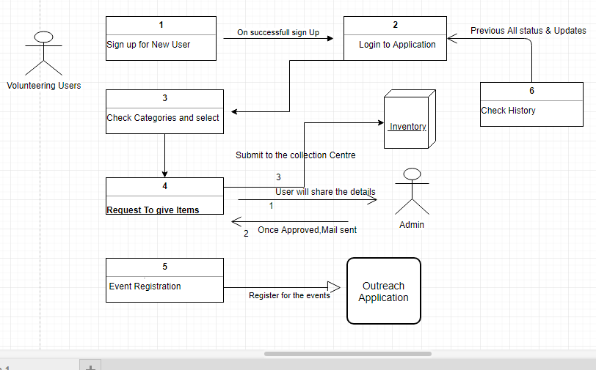

Figure 1: Use Case Interaction Diagram for Volunteering Users

* 1. **Outreach Volunteer User**
* Outreach Volunteer users will sign-up on the application. Upon activation of their account, they will be able to login into the application. The activation of Outreach volunteer users accounts will be done by Application Administrators. Upon activation, Outreach Volunteer user will get an intimation using email.
* Once Outreach Volunteer logs into the application, user will be able to see the dashboard made specifically for Outreach Volunteer users where they can see what all items are present in different Collection/Inventory Centre.
* They can view Inventory details and can place request for items in inventory as per the needs they have analyzed and for which they will be volunteering. These requests for items need to be approved by Application Administrators.
* Once item requests are approved, inventory status would be updated, and so will the request status for the Outreach Volunteering user. Outreach Volunteering user will be intimated via email. Outreach Volunteer user can work on the assignment and update the request mentioning where and for whom they have used the items from inventory.
* Outreach Volunteering users can view list of requests made by them, and their current status in their dashboard. In other words, all the history details for the Outreach Volunteering user will be readily available in user’s dashboard.
* Outreach Volunteer users can also put in requests for offering their belongings to needy, the same way like a Volunteering User has option to do. All the features applicable for a Volunteering User is also applicable for an Outreach Volunteering User.
* Collection of items from the inventory and delivering it to the needy ones is manual and the application is not offering shipment use cases, and is aligned to the way at present Outreach Volunteers are currently working in Cognizant.
* Outreach Volunteer user can generate report based on the list of requests they have worked upon and which all people/NGOs have benefited from his work.

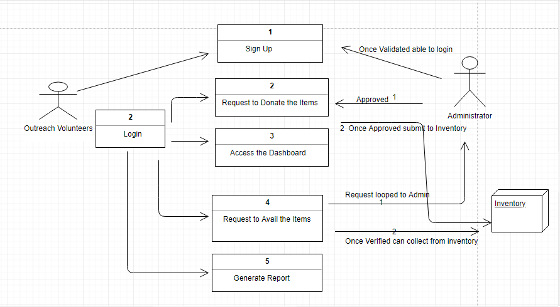

Figure 2 : Use Case Interaction Diagram for Outreach Volunteer Users

* 1. **Application Administrator User**
* There will be one hard coded administrator user credentials in the database. Using this credentials, the first administrator user can login, and view the admin user creation dashboard as well as inventory details dashboard. The first user can create other Application Administrator users.
* Application Administrator User will have option to see list of users belonging to different role. Administrator will be playing the vital role in maintaining the application as they have the right to deactivate the user based on violations of code of conduct.
* Application Administrator users can approve/reject offering requests of Volunteering User. An email with details will be sent to the Volunteering user.
* Application Administrator users can approve/reject account creation requests for Outreach Volunteer Users. An email with details will be sent to the Outreach Volunteering user.
* Application Administrator users can approve/reject item collection requests from inventory by Outreach Volunteering user. An email with details will be sent to the Outreach Volunteer user. If approved, the Outreach Volunteering User can collect requested items from Inventory/Collection Centre for the distribution to the needy.
* Application Administrator users can check status of items in Inventory/Collection Centre and can do necessary updates.
* Application Administrator users can generate several reports:
  + Report for items collected in inventory for a particular Collection Centre during a time span.
  + Report for any Outreach Volunteer User on what all request/work has been done by the Outreach Volunteer User during a time span.
* Application Administrator Users only will have access to DB where necessary update can be done as per the need of the application.
* Application Administrator users can post updates about Engagement programs being organized by Outreach.

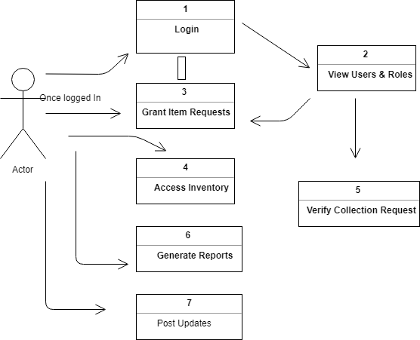

Figure 3- Use Case Interaction Diagram for Application Administrator

# Process Flow Diagram for #GiveAwayApp

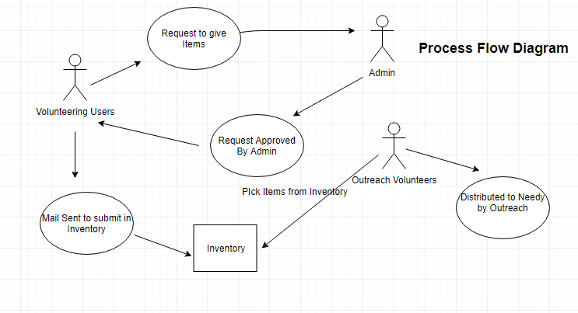

# Micro Service Architecture Implementation Overview

The application will be based on Micro Service Architecture, where in each individual working module is segregated as a separate Micro Service.

At present the #GiveAwayApp is going to implemented with 4 micro services, namely:

* User Management System
* Inventory Management System
* Mail Delivery System
* Event Management System
* Reporting System

The architecture is so designed, that it is very much easier to scale in future for enhancements and has scope for easier integration with newer micro services and third party user applications as well.

The #GiveAwayApp follows the standard micro service architecture as shown below:

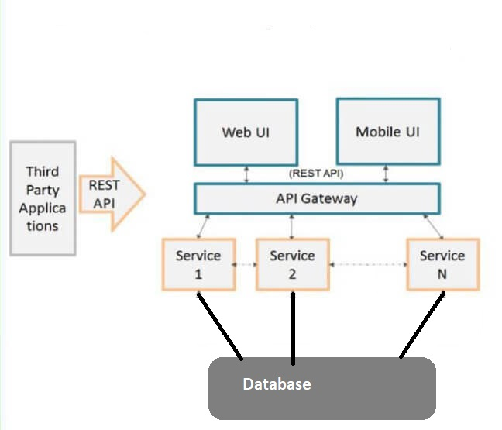

Figure 4 Micro Service Architecture Diagram

1. **User Management System**: This micro service targets all the operations related to users who would be using this application. The architecture and flow of this service is self-explanatory through the diagram depicted below:

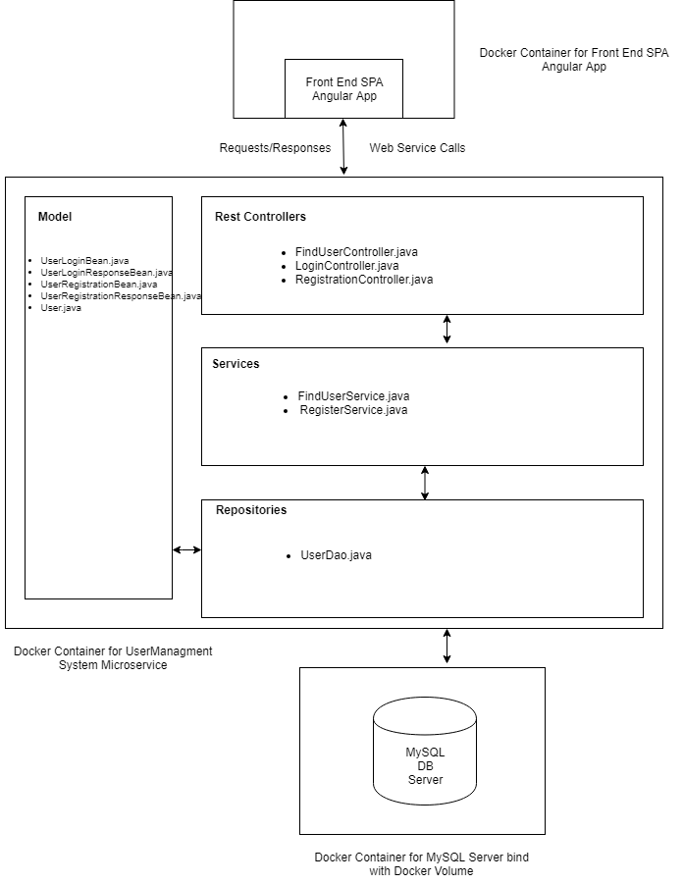This micro service is responsible for:

* 1. Registration of new users.
  2. Authentication and Authorization of users for login.
  3. Activation of user accounts.
  4. Deactivation of user accounts.
  5. Serving response for different user roles which is used to present different UI for different user roles.

1. **Inventory Management System**: This micro service targets all the operations related to management of inventory which is the core of this application. The architecture and flow of this service is self-explanatory through the diagram depicted below:

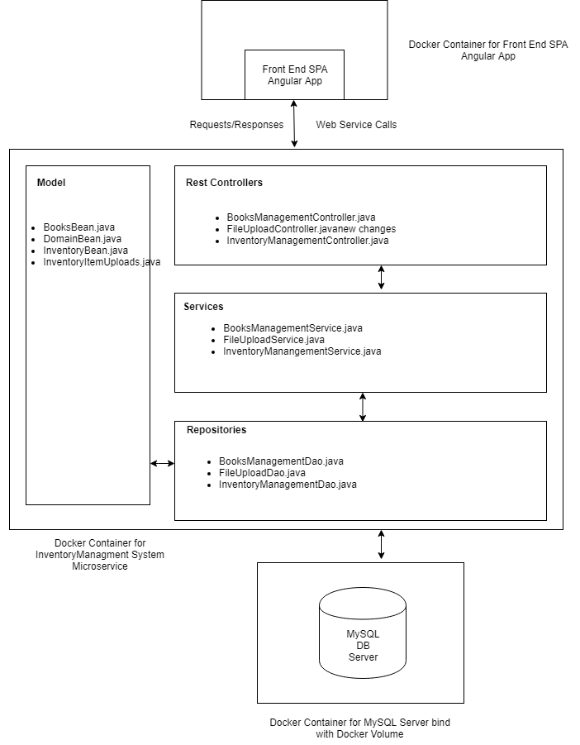  
  
This micro service is responsible for:

1. Placing requests for belongings from users.
2. Approval/Rejection of placed user requests.
3. Updating status of inventory items at every stage.
4. **Mail Delivery System**: This micro service targets all the operations related to messaging/mailing and intimating the users using this application at every stage in the application. The architecture and flow of this service is self-explanatory through the diagram depicted below:  
     
   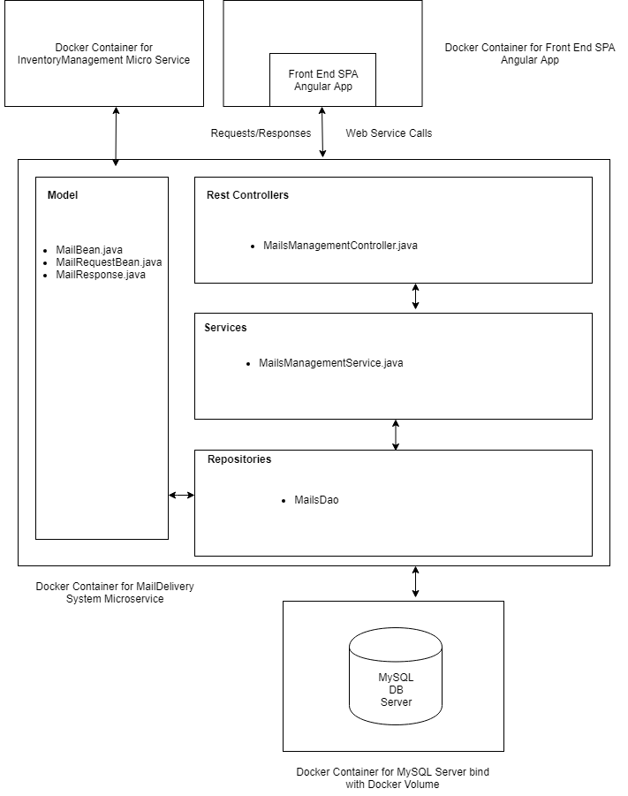  
     
   This micro service is responsible for:
5. Sending mails to user’s registered mail.
6. Maintaining records of sent messages.
7. **Event Management System**: This micro service targets all the operations related to managing events related operations targeted for this application. The architecture and flow of this service is self-explanatory through the diagram depicted below:

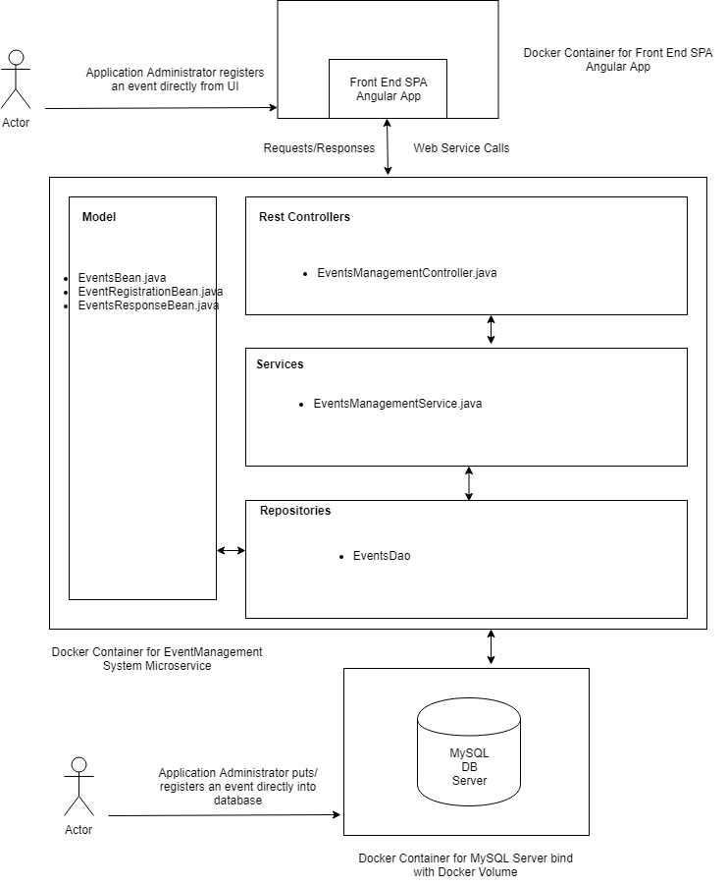

This micro service is responsible for:

1. Creation of new events.
2. Scheduling of events.
3. Exposing event details.
4. **Reporting System:** This micro service targets all the operations related to generating different types of reports offered by the application. The architecture and flow of this service is self-explanatory through the diagram depicted below:  
     
   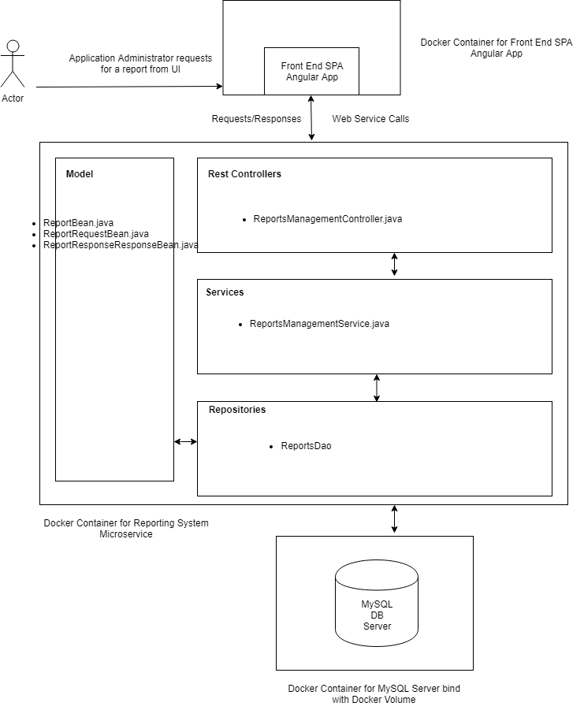

This micro service is responsible for:

1. Report for items collected in inventory for a particular Collection Centre during a time span.
2. Report for any Outreach Volunteer User on what all request/work has been done by the Outreach Volunteer User during a time span.

# Database Design

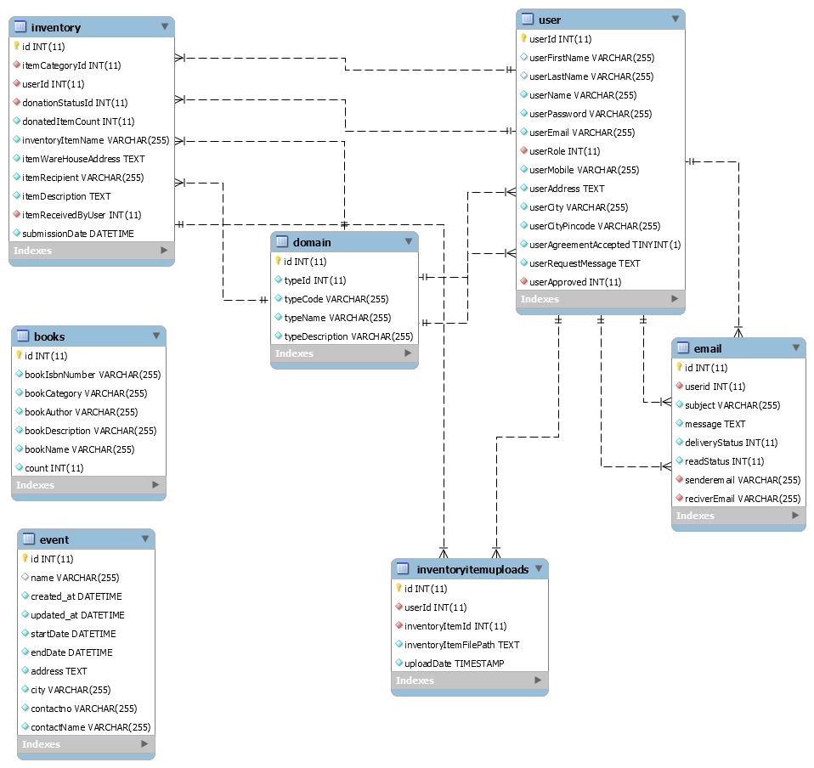

Figure 5: Database Design Diagram

# References

|  |  |  |
| --- | --- | --- |
| **Reference Document / Supporting Document** | **Document Name** | **Document** |
| NA | NA | NA |